SWITCHING CIRCUITS
In any logic circuit the basic building block is a logic gate. The logic gates are implemented using transistors and that a number of different technologies exist. The logic variables can take the values 0 and 1. In a circuit physically these values can be represented either as levels of voltage or current. The simplest and most popular representation is using voltage levels. To represent two logic values, a threshold voltage is defined. Any voltage below the threshold represents one logic value, and voltages above the threshold correspond to the other logic value. Usually, logic 0 is represented by the low voltage levels and logic 1 by the high voltages, which is known as a positive logic system. To implement the threshold-voltage concept, a range of low and high voltage levels is defined as shown in the following figure.
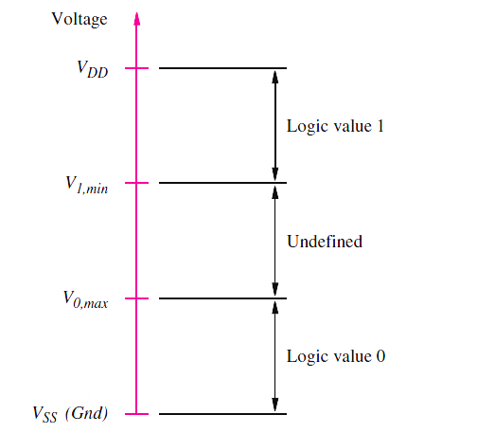
Minimum voltage is VSS, maximum voltage is VDD. We will assume that VSS is 0 volts, corresponding to electrical ground, denoted Gnd. The voltage VDD represents the power supply voltage. The voltages in the range Gnd to V_{0, max} represent logic value 0. V_{0, max} is the maximum voltage level that a logic circuit must recognize as low. Similarly, the range from V_{1, min} to VDD corresponds to logic value 1, and V_{1, min} is the minimum voltage level that a logic circuit must interpret as high.
Transistor Switches:
A transistor operates as a simple switch. The most popular type of transistor for implementing a simple switch is the metal oxide semiconductor field-effect transistor (MOSFET). There are two different types of MOSFETs, known as n-channel, abbreviated NMOS, and p-channel, denoted PMOS.
NMOS Transistor as a switch:

NMOS Transistor

A simple switch controlled by the input x

Simplified symbol for an NMOS transistor
NMOS transistor has four electrical terminals, called the source, drain, gate, and substrate. In logic circuits the substrate (also called body) terminal is connected to Gnd. So the simplified graphical symbol which omits the substrate node is used. The source and drain terminals are distinguished in practice by the voltage levels applied to the transistor; by convention, the terminal with the lower voltage level is deemed to be the source.
NMOS transistor is controlled by the voltage V_{G} at the gate terminal. If V_{G} is low, then there is no connection between the source and drain, and we say that the transistor is turned off. If V_{G} is high, then the transistor is turned on and acts as a closed switch that connects the source and drain terminals.
PMOS Transistor as a switch:
PMOS transistor symbol
Simplified symbol for an PMOS transistor
PMOS transistors have the opposite behaviour of NMOS transistors. The symbol and the simplified symbol are shown in the Figures above. In logic circuits, the substrate of the PMOS transistor is always connected to VDD. If V_{G} is high, then the PMOS transistor is turned off and acts like an open switch. When V_{G} is low, the transistor is turned on and acts as a closed switch that connects the source and drain. In the PMOS transistor the source is the node with the higher voltage.
Following figures summarize the typical use of NMOS and PMOS transistors in logic circuits
- NMOS transistor
- PMOS transistor
NMOS and PMOS transistors in logic circuits.
NMOS Logic Gates:
A NOT gate:
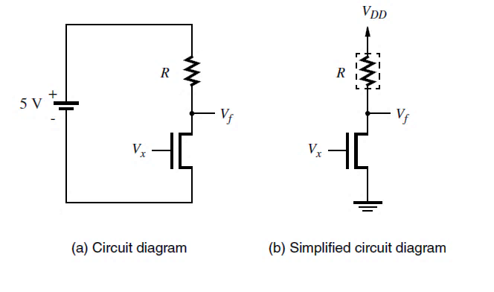
When V_{x} = 0V, the NMOS transistor is turned off. No current flows through the resistor R, and V_{f} = 5V. On the other hand, when V_{x} = 5V, the transistor is turned on and pulls V_{f} to a low voltage level. If V_{f} is viewed as a function of V_{x}, then the circuit is an NMOS implementation of a NOT gate. In logic terms this circuit implements the function f = x’. The purpose of the resistor in the NOT gate circuit is to limit the amount of current that flows when V_{x} = 5V.
NMOS Realization of a NAND Gate:
If V_{x1} = V_{x2} = 5V, both transistors will be on and V_{f} will be close to 0V. But if either V_{x1} or V_{x2} is 0, then no current will flow through the series-connected transistors and V_{f} will be pulled up to 5V. The realized function is the NAND function.
NMOS Realization of a NOR Gate:
If either V_{x1} = 5V or V_{x2} = 5V, then V_{f} will be close to 0V. Only if both V_{x1} and V_{x2} are 0 will V_{f} be pulled up to 5V. It shows the NOR function.
NMOS realization of a AND Gate
In NMOS Technology a AND gate is built using a NAND gate followed by an inverter. Node A realizes the NAND of inputs x1 and x2, and f represents the AND function.
NMOS realization of an OR Gate:
An OR gate is realized as a NOR gate followed by an inverter.
CMOS Logic Gates:
The most popular approach that uses both NMOS and PMOS transistors together is the CMOS Technology.
In NMOS circuits, the logic functions are realized by arrangements of NMOS transistors, combined with a pull-up device that acts as a resistor. The part of the circuit that involves NMOS transistors is called as the pull-down network (PDN). The pull-up device is replaced by a pull-up network (PUN) that is built using PMOS transistors, such that functions realized by the PDN and PUN networks are complements of each other.
Structure of a NMOS circuit:
Structure of a CMOS circuit:
For any given valuation of the input signals, either the PDN pulls V_{f} down to Gnd or the PUN pulls V_{f} up to VDD. The PDN and the PUN have equal numbers of transistors, which are arranged so that the two networks are duals of one another. Wherever the PDN has NMOS transistors in series, the PUN has PMOS transistors in parallel, and vice versa.
CMOS realization of a NOT Gate:
When V_{x} = 0V, transistor T₂ is off and transistor T₁ is on. This makes V_{f} = 5V, and since T₂ is off, no current flows through the transistors. When V_{x} = 5V, T₂ is on and T₁ is off. Thus
V_{f} = 0V, and no current flows because T₁ is off.
A key point is that no current flows in a CMOS inverter when the input is either low or high. This is true for all CMOS circuits; no current flows, and hence no power is dissipated under steady state conditions. This property has led to CMOS becoming the most popular technology in use today for building logic circuits.
CMOS realization of a NAND Gate:
This circuit can be derived from the logic expression that defines the NAND operation, f=(x₁x₂)’ = x₁’ + x₂’. This expression specifies the condition for which f=1; hence it defines PUN. In PUN an input variable x_{i} turn on a transistor if x_{i}=0. Thus f=1 when either input x₁ or x₂ has the value 0, which means PUN must have 2 PMOS transistors connected in parallel.
The PDN must implement complement of f, f’ = x₁x₂. Since f’ is 1 when both x₁ and x₂ are 1, it follows that PDN must have 2 NMOS transistors connected in series.
CMOS realization of a NOR Gate:
The circuit for a CMOS NOR gate is derived from the logic expression that defines the
NOR operation f = (x1 + x2 )’= x1’x2’.
Since f = 1 only if both x1 and x2 have the value 0, then the PUN consists of two PMOS transistors connected in series. The PDN, which realizes f’= x1 + x2, has two NMOS transistors in parallel, leading to the circuit shown above.
Programmable Logic Devices:
It is possible to manufacture chips that contain relatively large amounts of logic circuitry with a structure that is not fixed. Such chips are called programmable logic devices (PLDs). Two main types of PLDs are Programmable Logic Array (PLA) and Programmable Array Logic (PAL).
Programmable Logic Array (PLA):
A PLA comprises a collection of AND gates that feeds a set of OR gates.
As shown in the figure above, the PLA’s inputs x₁, . . . , x_{n} pass through a set of buffers (which provide both the true value and complement of each input) into a circuit block called an AND plane, or AND array. The AND plane produces a set of product terms P₁, . . . , P_{k} . Each of these terms can be configured to implement any AND function of x₁, . . . , x_{n}. The product terms serve as the inputs to an OR plane, which produces the outputs f₁, . . . , f_{m}. Each output can be configured to realize any sum of P₁, . . . , P_{k} and hence any sum-of-products function of the PLA inputs.
A more detailed diagram of a small PLA is given below, which shows a PLA with three inputs, four product terms, and two outputs. Each AND gate is depicted as a single horizontal line attached to an AND-gate symbol. The possible inputs to the AND gate are drawn as vertical lines that cross the horizontal line. At any crossing of a vertical and horizontal line, a programmable connection, indicated by an X, can be made. Each OR gate is drawn in a similar manner, with a vertical line attached to an OR-gate symbol. The AND-gate outputs cross these lines, and corresponding programmable connections can be formed. The PLA is efficient in terms of the area needed for its implementation on an integrated circuit chip. For this reason, PLAs are often included as part of larger chips, such as microprocessors. In this case a PLA is created so that the connections to the AND and OR gates are fixed, rather than programmable. It is possible to program the AND and OR gates.
Here, the AND gate that produces P1 is shown connected to the inputs x1 and x2. Hence P1 = x1x2. Similarly, P2 = x1x3, P3 = x1x2x3, and P4 = x1x3. Output f1 is connected to product terms P1, P2, and P3. It therefore realizes the function f1 = x1x2 + x1x3 + x1x2x3. Similarly, output f2 = x1x2+x1x2x3+x1x3. By programming the AND and OR planes differently, each of the outputs f1 and f2 could implement various functions of x1, x2, and x3. Commercially available PLAs come in larger sizes than we have shown here. Typical parameters are 16 inputs, 32 product terms, and eight outputs.
Example: Implement using PLA
F1(A,B,C)=∑m(0,1,6,7)
F2(A,B,C)=∑m(2,3,4,5)
Refer class notes
Programmable Array Logic (PAL):
The PLAs are hard to fabricate and the speed-performance of circuits implemented in the PLAs are reduced because both AND and OR planes are programmable. These drawbacks led to the development of a similar device in which the AND plane is programmable, but the OR plane is fixed. Such a chip is known as a programmable array logic (PAL). Because they are simpler to manufacture, and thus less expensive than PLAs, and offer better performance, PALs have become popular in practical applications.
An example of a PAL with three inputs, four product terms, and two outputs is given in the figure below.
The product terms P1 and P2 are hardwired to one OR gate, and P3 and P4 are hardwired to the other OR gate. The PAL is shown programmed to realize the two logic functions f1 = x1x2x3 +x1x2x3 and f2 = x1x2 +x1x2x3.
Example: Implement using PAL
F1(A,B,C)=∑m(0,1,6,7)
F2(A,B,C)=∑m(2,3,4,5)
Refer class notes
Noise Margin:
Consider the two NOT gates shown below:
Let us refer to the gates on the left and right as N1 and N2, respectively. Electronic circuits are constantly subjected to random perturbations, called noise, which can alter the output voltage levels produced by the gate N1. It is essential that this noise not cause the gate N2 to misinterpret a low logic value as a high one, or vice versa. Consider the case where N1 produces its low voltage level VOL. The presence of noise may alter the voltage level, but as long as it remains less than VIL, it will be interpreted correctly by N2. The ability to tolerate noise without affecting the correct operation of the circuit is known as noise margin. For the low output voltage, we define the low noise margin as
NML = VIL − VOL
A similar situation exists when N1 produces its high output voltage VOH. Any existing noise in the circuit may alter the voltage level, but it will be interpreted correctly by N2 as long as the voltage is greater than VIH. The high noise margin is defined as
NMH = VOH – VIH
Fan in and Fan out:
The fan-in of a logic gate is defined as the number of inputs to the gate. Depending on how a logic gate is constructed, it may be impractical to increase the number of inputs beyond a small value.
In real circuits each logic gate may be required to drive several others. The number of other gates that a specific gate drives is called its fan-out.
Power Dissipation in Logic Gates:
In an electronic circuit it is important to consider the amount of electrical power consumed by the transistors. Integrated circuit technology allows fabrication of billions of transistors on a single chip; hence the amount of power used by an individual transistor must be small.
Consider the NMOS inverter shown below:

When Vx = 0, no current flows and hence no power is used. But when Vx = 5 V, power is consumed because of the current flowing through the transistor.
Consider the CMOS inverter shown below:
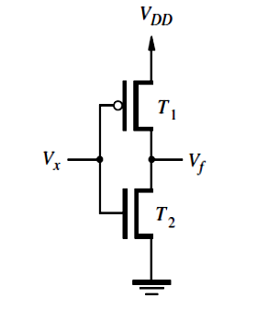
When the input Vx is low, no current flows because the NMOS transistor is off. When Vx is high, the PMOS transistor is off and again no current flows. Hence no current flows in a CMOS circuit under steady-state conditions. Current does flow in CMOS circuits, however, for a short time when signals change from one voltage level to another.
To distinguish between power consumed during steady-state conditions and power consumed when signals are changing, it is customary to define two types of power. Static power is dissipated by the current that flows in the steady state, and dynamic power is consumed when the current flows because of changes in signal levels. NMOS circuits consume static power as well as dynamic power, while CMOS circuits consume mostly dynamic power.
Figure (a) depicts the following situation. Assume that Vx has been at 0 V for some time; hence V_{f} = 5 V. Now let Vx change to 5 V. The NMOS transistor turns on, and it pulls V_{f} toward GND. Because of the parasitic capacitance C at node f, voltage V_{f} does not change instantaneously, and current I_{D} flows through the NMOS transistor for a short time while the capacitor is being discharged. A similar situation occurs when Vx changes from 5 V to 0, as illustrated in Figure (b). Here the capacitor C initially has 0 volts across it and is then charged to 5 V by the PMOS transistor. Current flows from the power supply through the PMOS transistor while the capacitor is being charged.
The power used by a single CMOS inverter is extremely small. Consider again the situation in Figure (a) when V_{f} = VDD. The amount of energy stored in the capacitor is equal to CV_{DD}² /2. When the capacitor is discharged to 0 V, this stored energy is dissipated in the NMOS transistor. Similarly, for the situation in Figure (b), the energy CV_{DD}² /2 is dissipated in the PMOS transistor when C is charged up to V_{DD}. Thus for each cycle in which the inverter charges and discharges C, the amount of energy dissipated is equal to CV_{DD}². Since power is defined as energy used per unit time, the power dissipated in the inverter is the product of the energy used in one discharge/charge cycle times the number of such cycles per second, f. Hence the dynamic power consumed is
P_{D} = f CV_{DD}²
In practice, the total amount of dynamic power used in CMOS circuits is significantly lower than the total power needed in other technologies, such as NMOS. For this reason, virtually all large integrated circuits fabricated today are based on CMOS technology.
Buffers:
A buffer is a logic gate with one input, x, and one output, f, which produces f = x. The simplest implementation uses two inverters as shown below. Buffers are used for driving higher than normal capacitive loads.
Non-inverting Buffers:
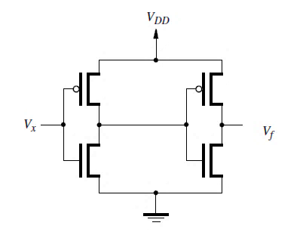
(a) Implementation of a buffer (b) Graphical symbol
Inverting Buffer:
It produces the same output as an inverter, f = x, but is built with relatively large transistors. The graphical symbol for the inverting buffer is the same as for the NOT gate; an inverting buffer is just a NOT gate that is capable of driving large capacitive loads.
Tri-state Buffers:
A tri-state buffer has one input, x, one output, f, and a control input, called enable, e. The enable input is used to determine whether or not the tri-state buffer produces an output signal. When e = 0, the buffer is completely disconnected from the output f. When e = 1, the buffer drives the value of x onto f, causing f = x. When e = 0, the output is denoted by the logic value Z, which is called the high-impedance state.
Types of tri-state buffers:
Figure below shows several types of tri-state buffers. The buffer in part (b) has the same behaviour as the buffer in part (a), except that when e = 1, it produces f = x’. Part (c) of the figure gives a tri-state buffer for which the enable signal has the opposite behaviour; that is, when e = 0, f = x, and when e = 1, f = Z. The term often used to describe this type of behaviour is to say that the enable is active low. The buffer in Figure (d) also features an active-low enable, and it produces f = x’ when e = 0.

Application of Tri state buffer:
Consider the circuit in the Figure below. In this circuit the output f is equal to either x1 or x2, depending on the value of s. When s = 0, f = x1, and when s = 1, f = x2.
In this circuit, the outputs of the tri-state buffers are wired together. This connection is possible because the control input s is connected so that one of the two buffers is guaranteed to be in the high-impedance state. The x1 buffer is active only when s = 0, and the x2 buffer is active only when s = 1. It would be disastrous to allow both buffers to be active at the same time. Doing so would create a short circuit between VDD and Gnd as soon as the two buffers produce different values. For example, assume that x1 = 1 and x2 = 0. The x1 buffer produces the output VDD, and the x2 buffer produces Gnd. A short circuit is formed between VDD and Gnd, through the transistors in the tri-state buffers. The kind of wired connection used for the tri-state buffers is not possible with ordinary logic gates, because their outputs are always active; hence a short circuit would occur.
Transmission Gates:
It is possible to combine an NMOS and a PMOS transistor into a single switch that is capable of driving its output terminal either to a low or high voltage equally well. Figure below gives the circuit for a transmission gate.
As indicated in parts (b) and (c) of the figure, it acts as a switch that connects x to f. Switch control is provided by the select input s and its complement s. The switch is turned on by setting Vs = 5V and Vs’ = 0. When Vx is 0, the NMOS transistor will be turned on (because VGS = Vs −Vx = 5V) and Vf will be 0. On the other hand, when Vx is 5V, then the PMOS transistor will be on (VGS = Vs’ − Vx = −5 V) and Vf will be 5V.
Transmission gates can be used in a variety of applications.
Exclusive-OR Gates:
Figure below gives a circuit for an XOR gate that uses two transmission gates and two inverters. The output f is set to the value of x2 when x1 = 0 by the top transmission gate. The bottom transmission gate sets f to x2’ when x1 = 1.
Multiplexer Circuit:
Figure below shows a 2 to 1 multiplexer built with transmission gates.
The select input s is used to choose whether the output f should have the value of input x1 or x2. If s = 0, then f = x1; if s = 1, then f = x2.

